
Municipality of the County of Kings
Report to the Planning Advisory Committee
APPLICATION TO ENTER INTO A DEVELOPMENT AGREEMENT TO PERMIT A COMPREHENSIVE NEIGHBOURHOOD DEVELOPMENT
(File #22-07)
DATE: May 3, 2023
Prepared by: Planning and Development Services

Applicant | Michael Napier, MNA
Land Owner | Bradford and Constance Hopgood  3019538 Nova Scotia Limited
Proposal | Comprehensive neighbourhood development consisting of three multi-unit dwellings, one two unit dwelling and a community commercial use
Location | 1207 Belcher Street (PIDs 55030092, 55523153, 55037915, 55534978)
Lot Area | 12.05 acres (525,054 square feet)
Designation | Residential
Zone | Residential Mixed Density (R3) Zone  Comprehensive Neighbourhood Development (R5) Zone  ESA Overlay
Surrounding Uses | Primarily low density residential uses, agricultural uses, limited industrial and educational uses
Neighbour Notification | 12 letters sent to property owners within 500 feet of the subject properties

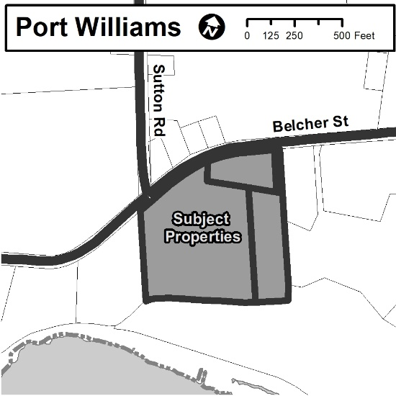
PROPOSAL
Michael Napier, of Michael Napier Architecture, has applied on behalf of Bradford Hopgood to enter into a development agreement to permit the development of a comprehensive neighbourhood development on lands located in the southwest portion of the Growth Centre of Port Williams.
The proposal consists of three multi-unit dwellings containing 67 units each, one new two-unit dwelling, an existing one-unit dwelling and a community commercial space.

OPTIONS
In response to the application, the Planning Advisory Committee may:
- Recommend that Council approve the development agreement as drafted;
- Provide alternative direction, such as requesting further information on a specific topic, or recommending changes to the draft development agreement;
- Recommend that Council refuse the development agreement as drafted.

STAFF RECOMMENDATION
Staff recommend that the Area Advisory Committee forward a positive recommendation by passing the following motion.
The Port Williams Area Advisory Committee recommends that the Planning Advisory Committee recommends that Municipal Council give Initial Consideration to and hold a Public Hearing regarding entering into a development agreement to permit a comprehensive neighbourhood development at 1207 Belcher Street and associated properties (PID 550300092, 55523153, 55534978 and 55037915) which is substantively the same (save for minor differences in form) as the draft set out in Appendix D of the report dated May 3rd, 2023.

BACKGROUND
Two of the subject properties are owned by Bradford and Constance Hopgood, one of which is developed with their primary residence. The other property is a small strip of land having a width of roughly 30 feet and serves, primarily, as access to the property to the rear, which is also a subject property of this proposal. These two properties were acquired by the Hopgoods in 2015.
The two other subject properties are owned by a numbered company in which Constance Hopgood is listed as the President. These properties located to the rear of the properties discussed above have been owned since 1998 and, until this application, were used as a sand quarry. The lifespan of the sand quarry has reached its end and the owners are seeking to redevelop the properties for residential development.

SITE INFORMATION
As previously mentioned, there are four parcels that form the subject properties. The vacant parcel fronting on Belcher Street and west of the one unit dwelling belonging to the Hopgoods has an approximate lot area of 8 acres with approximately 450 feet of frontage. The other parcel used as part of the sand quarry has no road frontage and approximately 2.5 acres of lot area.
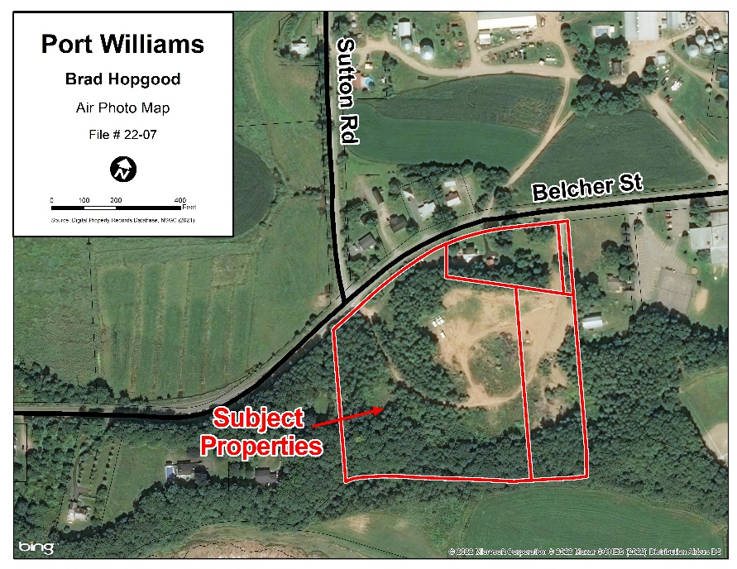
The other two parcels are not proposed to have extensive development but they have a total lot area of approximately 67,675 square feet (1.55 acres). Much of these lands are to remain undeveloped, save for the use of the easternmost portion of the property which is intended to serve as one of the driveways accessing the proposed development. The one-unit dwelling occupied by the Hopgoods is not intended to be altered as a result of this proposal but it is included in the land area covered by the development agreement.
To the rear of the property, north of the area used for sand extraction, there is a vegetated area consisting of mature trees. This vegetation is intended to remain to serve as a buffer between the proposed development and the existing dwelling. Beyond the trees the subject properties slope downward toward the Cornwallis River. The proposed development is intended to be located primarily within the former sand quarry.
The subject properties are located in the southwest portion of the Growth Centre of Port Williams. The lands to the west and to the north beyond the Belcher Street frontage are primarily in agricultural production and are zoned for this use. Lands in agricultural production are mostly located outside the boundaries of the Growth Centre, save for a small portion of the lands on the north side of Belcher Street, adjacent to the subject properties. There is an elementary school to the east of the subject properties. Otherwise the area surrounding the subject properties has been developed with one unit dwellings although the area has been zoned for all types of residential units including multi-unit dwelling containing up to eight residential units.
Public Information Meeting
Council’s Planning Policy PLAN-09-001 requires a Public Information Meeting (PIM) for all new uses which are to be considered by development agreement. A virtual Public Information Meeting was recorded and posted on the Municipality’s website starting on March 10, 2022. Correspondence received in response to the Public Information Meeting is included as Appendix C.
Staff received a letter from a neighbouring farmer expressing concern over negative impacts on his farming operation as a result of the proposed development. His main concerns related to traffic generation in an area where there is also a school zone that results in traffic back ups in combination with the movement of farm vehicles. While these concerns are understandable, much of these conditions pre-date the application for development on this property and additional traffic would be generated as a result of any development on the subject property. The applicant has prepared a Traffic Impact Study that has been reviewed by the provincial Department of Public Works which has approved the study and has indicated it has no concerns related to traffic generation.
Staff also heard from other neighbours concerned about traffic and the destruction of the habitat of bank swallows, an endangered species. The neighbours indicate that habitat has already been destroyed on the subject properties. With regard to this assertion, the provincial Department of Environment attended the site and did not find any evidence that nesting had occurred.

POLICY REVIEW
Land Use By-law
In order for Council to be able to consider a development agreement, the Municipal Government Act (‘MGA’) requires that this ability be outlined within the Land Use By-law (‘LUB’). Section 4.7.4 of the LUB states that,
Pursuant to the Municipal Planning Strategy, the uses noted below may be considered by Development Agreement within the Comprehensive Neighbourhood (R5) Zone.
- The development of comprehensive planned neighbourhood developments in accordance with policies 3.1.13 and 3.114 of the Municipal Planning Strategy.
Municipal Planning Strategy
Enabling Policy
The Comprehensive Neighbourhood Development (R5) Zone is generally applied to large properties within the Residential Designation in order to ensure that development is planned in a comprehensive manner that considers the impacts on future development on neighbouring vacant parcels and on existing properties. It enables Council to consider the overall design of a development that may have otherwise occurred in several uncoordinated phases without oversight over the development of the entire site.
The Municipal Planning Strategy contains specific direction related to this type of development contained in policies 3.1.13 and 3.1.14. The subject properties include two parcels within the Residential Mixed Density (R3) Zone. While the policies within this section apply exclusively to properties within the Residential Comprehensive Development (R5) Zone, policy 3.1.14 addresses proposals that include properties in more than one zone:
3.1.14 Council shall consider including lands outside the Comprehensive Neighbourhood Development (R5)
Zone in a development agreement that applies primarily to lands within the Comprehensive Neighbourhood Development (R5) Zone without an amendment to the Land Use By-law to expand the zone. In considering such an addition Council shall be satisfied that:
(a) the lands abut a Comprehensive Neighbourhood Development (R5) Zone; and
(b) the lands in the Comprehensive Neighbourhood Development (R5) Zone development agreement demonstrably contributes to protecting natural features, improving transportation linkages or facilitating the development of isolated properties;
The two parcels that are located within the Residential Mixed Density (R3) Zone abut the larger parcel that is zoned Comprehensive Neighbourhood Development (R5). The easternmost parcel is quite narrow, having a width of roughly 30 feet. As a result the property developed with the Hopgoods one unit dwelling is also proposed to be included to enable some flexibility related to the driveway location, if necessary. It is Staff’s opinion that, based on policy 3.1.14, they can be included as part of this development agreement application.
Policy 3.1.13 provides the criteria to be used by Council to assess the appropriateness of the proposed development. Several of the policies relate to the revenue and costs associated with development.
Policies 3.1.13 states,
“Council shall consider only by development agreement proposals for comprehensive planned neighbourhood developments within the Comprehensive Neighbourhood Development (R5) Zone. In evaluating such development agreements, Council shall be satisfied that the proposal:
(a) consists of land uses that are consistent with the intent of the Residential Designation, including but not limited to residential uses, community facilities, recreational facilities and commercial uses intended to serve the neighbourhood;
(b) provides a mix of housing options rather than only one building type;
The proposal consists of three multi-unit dwellings, an existing one unit dwelling and a second, two unit dwelling, and a commercial space intended to primarily serve local residents. Other than the multi-unit dwellings, proposed to be located at the rear of the property, the other uses are oriented to the road frontage. While the dwellings proposed at the front of the property are to be maintained as lower density development, since the property containing the one unit dwelling is currently located in the Residential Mixed Density (R3) Zone, flexible development permissions consistent with those of the Residential Medium Density (R3) Zone been provided in the development agreement.
The commercial space, which is proposed to be subject to the Mixed Commercial Residential (C3) Zone is consistent with the concept of neighbourhood residential uses. The Mixed Commercial Residential (C3) Zone is enabled in the Residential Designation.
(c) has an overall minimum density of four (4) units/acre for developments serviced by central sewer and water and similar density for unserviced developments provided the environment can sustainably support the proposed density;
A total of 204 residential units is proposed for 12.05 acres resulting in an overall density of just under 17 units per acre. The proposed development will be serviced by central water and sewer services and, as a result, this density is appropriate and meets the requirements of the policy.
(d) has a neutral or positive long-term impact on municipal finances, as shown by a fiscal impact analysis, or the community or environmental benefits outweigh the costs;
The development will not result in costs to the Municipality. Development of a parcel having a lot area consistent with the subject properties would normally result in subdivision involving a transfer of ownership of said infrastructure to the Municipality, typically in the form of roads, water and sewer piping as part of a broader subdivision process. While there is subdivision proposed in this application, it does not include new road infrastructure. Any new water and sewer infrastructure required falls within the jurisdiction of the Village of Port Williams. The property owner is working with the Village to extend the required infrastructure in a way that is acceptable to the Village.
Staff consulted with the Manager of Revenue to gain an understanding of the financial benefits of the proposal. It is estimated that approximately $230,000 of tax revenue per year would be generated for the Municipality, at full buildout, on the basis of an estimated assessed value of $127,596 per apartment unit and $250,000 of assessed value for the commercial use. Revenue generated for the Village of Port Williams is estimated to be approximately $90,000 per year.
On this basis, Staff are satisfied that the development will have a positive impact on Municipal and Village finances sine there will be minimal costs generated due to limited infrastructure expansion and a significant increase in property tax revenues resulting from the proposed development.
(e) includes appropriate phasing to ensure orderly development that minimizes the creation of vacant parcels of land between the existing developed lands and the proposed site;
Since the proposed development is located to the rear of existing development, there will be no vacant parcels created between two developed areas. As such, no phasing is proposed.
(f) results in public infrastructure that is efficient to service and maintain;
The proposed development utilizes existing water infrastructure and therefore increases the overall efficiency of the system since the cost of servicing and maintenance will now benefit from additional ratepayers. The design of the sewer extension is to be negotiated between the Village of Port Williams and the property owner but will not serve significantly more properties than the subject properties. There is no reason to believe that this portion of the system would be designed in such a way as to be inefficient to service since the total number of new possible ratepayers outside this development is limited.
(g) encourages active transportation by providing sufficient sidewalks, pathways and/or trails consistent with the transportation infrastructure policies contained in section 2.3, Infrastructure;
A sidewalk is not currently provided on either side of Belcher Street in proximity of the subject properties. A sidewalk, owned and maintained by the Village of Port Williams begins on the south side of Belcher Street at the eastern property line of the Elementary School.
New sidewalks are typically provided when new roads are built, or are installed at a later date by the jurisdiction having authority or the Village of Port Williams in this circumstance. Where a new sidewalk would not provide additional connectivity within the Growth Centre since the existing sidewalk begins roughly 685 feet to the east, and since there are intervening parcels between the subject properties and the western property line of the school property, the Municipality is not requiring the installation of a new sidewalk on Belcher Street. Sidewalks meeting accessibility requirements will be provided along vehicular paths of travel within the subject properties to ensure pedestrian safety and to provide a continuous sidewalk network at such a time a sidewalk is installed along Belcher Street west of the elementary school. The proposed development would assist in the viability of a new sidewalk in this location due to the potential increase in population that would result.
(h) minimizes environmental impact by protecting sensitive natural features and incorporating low-impact approaches for managing storm water;
Staff are not aware of any sensitive features on the subject property. A resident indicated that they suspected that bank swallow habitat was previously destroyed however, a representative from Nova Scotia Environment and Climate Change investigated and did not see any of the typical characteristics of the habitat of the bank swallow. Staff are not aware of any other sensitive areas on site. A requirement for low impact stormwater management approaches has been written into the draft development agreement.
(i) provides a minimum 100-foot-wide vegetated buffer within Comprehensive Neighbourhood Development (R5) Zones adjacent to the Agricultural (A1) Zone. This buffer area must be entirely contained within the development and may be used for park, recreation and service utility purposes, but must not contain buildings for any other use. The width of the buffer area may be reduced where natural or built features, including but not limited to a ravine, watercourse or road create a buffer with the Agricultural (A1) Zone;
The area to the west of the subject properties is located within the Agricultural (A1) Zone. A minimum separation distance of 100 feet is provided. A walking trail and below grade parking is proposed to be located within this area, as considered by the policy above. The buffer is intended to provide a separation between residential uses and negative impacts associated with agriculture such as spraying and spreading of pesticides and fertilizers. These encroachments into the buffer are deemed to be appropriate since they do not constitute structures or permanent buildings that would serve to expose potential residents to those impacts on a prolonged basis.
(j) notwithstanding the minimum requirements set out in the Subdivision By-law, provides a minimum of ten (10) per cent open space contribution;
The property owners will be required to provide a 10 per cent contribution for open space at the time of subdivision. Given the design of the site, this contribution is proposed to be in the form of cash-in-lieu of land.
(k) utilizes, alternative road, lot, servicing and other infrastructure standards where appropriate;
This criteria is not applicable to this proposal.
(l) provides sufficient vehicle and pedestrian transportation linkages with any adjacent town, village or property through the dedication of land intended for use as a road reserve;
The proposed development will provide sidewalk infrastructure along both driveways where it will meet the public road frontage along Belcher Street for both pedestrians and vehicular traffic.
(m) complements existing and planned development within an adjacent town or village in location, design, and any linkages between town or village and Municipal infrastructure; and
The proposal includes higher density residential development and a community commercial use on the western edge of Port Williams. The area adjacent to this site is within the Residential Mixed Density (R3) Zone, which permits multi-unit residential development. The residential component of this development is similar to the residential uses permitted as -of-right in the surrounding area and the commercial component of the development will provide a commercial amenity in an area where there is little commercial activity.
(n) meets the general development agreement criteria set out in section 5.3 Development Agreements and Amending the Land Use By-law;
This will be reviewed in a later section within this report.
MPS Objectives
In evaluating applications for development, Municipal Staff review the MPS holistically on the basis of its overarching vision and objectives. The general approach to the MPS balances the interests of protecting agricultural land and the development of healthy and complete communities. Generally speaking, rural areas are intended to be maintained for resource production and extraction while more urban areas, identified as Growth Centres, are intended to accommodate the majority of other types of growth. This is intended to occur in ways that contribute to vibrant communities that incorporate a high level of active transportation and efficiency in providing infrastructure servicing that is efficient and cost-effective to maintain. This approach is outlined in the statements of the MPS, outlined below.
Within the Vision Statement related to Settlement, Council has identified the following priorities:
- Concentrate new commercial and residential development, including mixed uses, in the Growth Centres with clearly defined boundaries;
- Encourage efficient service and infrastructure delivery; and
- Enable and encourage a diversity of housing throughout the region
The proposed development includes primarily residential uses as well as a community commercial use within a Growth Centre. The proposed development does not include any new public infrastructure while increasing the total number of residents thereby increasing the efficiency of the infrastructure. The proposed development also increases the diversity of housing within the Growth Centre of Port Williams since larger scale multi-unit dwellings are not common within Port Williams.
Within the section related to infrastructure, the objective related to the theme of Settlement states, “To make effective use of existing infrastructure located within Growth Centres.”
This development will require the extension of sewer services through a cost sharing agreement between the property owner and the Village of Port Williams. Given the density of the proposed development, this infrastructure will be efficient to service and maintain. Further to the objective, policy 2.3.2 states that, ”Council shall encourage the development of higher density communities in Growth Centres that permit various housing types to increase the efficiency and cost-effectiveness of municipal sanitary sewer and water servicing;” The proposal represents a higher density development within a Growth Centre that permits a variety of permitted residential built forms, including multi-unit dwellings in proximity to the subject properties.
Within section 3.1 of the MPS, related to the Residential Designation, the objective related to the theme of Settlement states, “To accommodate a wide range of housing options, including opportunities for mixed uses and increased densities in areas where urban services are efficient to deliver.” The proposed development provides multi-unit dwellings at higher densities than is typical within the Growth Centre of Port Williams. This will assist in increasing the efficiency of providing services within the Growth Centre. This proposal also includes a commercial component, thereby incorporating a mix of uses.
The theme of Transportation encourages higher densities along main transportation corridors. Belcher Street is a main transportation corridor within the Municipality, thereby meriting consideration of higher density residential uses.
General Criteria
Municipal Planning Strategy section 5.3.7 contains the criteria to be used when considering all development agreement proposals. These criteria consider the impact of the proposal on the road network, services, development pattern, environment, finances, and wellfields, as well as the proposal’s consistency with the intent of the Municipal Planning Strategy.
It is Staff’s opinion that the proposal meets the general criteria. Staff have reviewed in that it will not result in any direct costs to the Municipality, is compatible with the surrounding development pattern, is compatible with adjacent uses, and raises no concerns regarding emergency services. Staff did investigate concerns related to traffic generation. The applicant had a Traffic Impact Study prepared to the satisfaction of the provincial Department of Public Works. Detailed responses to each criteria can be found in Appendix B.
Port Williams Secondary Plan
The Port Williams Secondary Plan forms section 4.5 of the MPS and provides specific policy direction within the boundaries of the Growth Centre of Port Williams. This section will discuss relevant policies contained within the Secondary Plan and how the proposal is consistent with these policies.
Policy 4.5.1 requires that all new development within the Growth Centre be serviced by central water and sewer services. There is not currently sewer service provided to the subject properties. The existing sewer line terminates in proximity to the Elementary School. The need to extend infrastructure to the subject site has been identified with the Village of Port Williams and the Village and the property owners are in discussions related to cost sharing the extension of sewer servicing. There is water infrastructure that services the subject properties and the proposed development will be required to connect at the time of permitting.
Policy 4.5.4 requires that all rezoning and development agreement applications be consistent with the requirements pertaining to wellfields in Port Williams. The proposed development is not within any wellfield protection overlay and is not expected to negatively impact the water supply.
With regard to residential development, the Secondary Plan states a goal, “To accommodate residential growth that meets the needs of residents form all stages and ages of life.” The Secondary Plan also states an objective of directing higher density developments to central locations and to direct lower density developments to the Growth Centre fringe. While this proposal is higher density and it is located on the fringe, Staff are of the opinion that, based on the visual screening provided by site characteristics including existing vegetation and site topography, there will be little visual impact of the higher density uses on neighbouring properties.
It should also noted that the central area of Port Williams is almost entirely developed with few vacant properties. The main transportation corridors in the central area exhibit traditional rural development patterns consisting of lower density uses clustered around the main intersection of Belcher Street and Highway 358. The balance of development within Port Williams has occurred relatively recently with major subdivision development occurring in the late 1980s, and over the course of the 2000s thus far. As a result, there is little land remaining within the core of the Growth Centre that is not currently zoned for industrial or commercial uses. The development of higher density residential uses within the core of the Growth Centre of Port Williams would require significant land assembly to be able to accommodate larger proposals. Redevelopment of these areas will likely occur in the fullness of time as buildings reach the end of their natural lifespan, but, until that time, there continues to be a great need for new housing throughout the region, and indeed, the province as a whole.
The policies of the MPS directs growth to Growth Centres which are intended to accommodate a variety of housing. The area surrounding the subject properties is zoned for moderate density within all manner of residential built form. Staff do not see any reason to limit development of the subject properties to lower density uses in light of the balance of considerations in the Growth Centre. Given the predominance of lower density built forms within the Growth Centre of Port Williams and in consideration of the other goals pertaining to the provision of a variety of housing types and the goal of the Secondary Plan pertaining to providing housing for people of all ages and stages of life, increasing the number of multi-unit dwellings will enable more people to age within the community.
Policy 4.5.24 outlines criteria to be considered when development of a Comprehensive Neighbourhood Development is proposed. The policies of the MPS were largely based on these policies which pre-date the adoption of the current MPS. As a result the policies are similar to those within the MPS and the analysis of similar policies will be kept brief. Please see the section on policies 3.1.13 and 3.1.14 for greater detail on these policies.
Policy 4.5.24 states:
Council shall:
4.5.24 consider only by development agreement in the Comprehensive Neighbourhood Development (R5) zone, residential development which is sympathetic to neighbouring farms and will not interfere with normal agricultural activities. In considering such development agreements Council shall be satisfied that:
(a) the density of the overall development is a minimum of 4 units per acre;
The proposed development has an approximate density of approximately 17 units per acre.
- development of the area shall be phased in such a manner as to allow the largest amount of agricultural land to remain in production as [long as] possible;
The proposed development does not include any land currently in agricultural production.
- a separation distance of a minimum of 100 feet (30.5 metres) shall be maintained between any residential building and land actively used for crop land and 600 feet (183 metres) shall be maintained between any residential building and land used for intensive livestock operations;
There is a large agricultural operation just beyond the edge of the Growth Centre and this operation includes a livestock operation. The aerial photo below identifies the nearest cropped area in yellow and the nearest building that could be used for livestock in black. The distance to the cropped area the nearest new residential use is in excess of 250 feet away. The distance from a new residential use and any building that might house livestock is in excess of 650 feet.
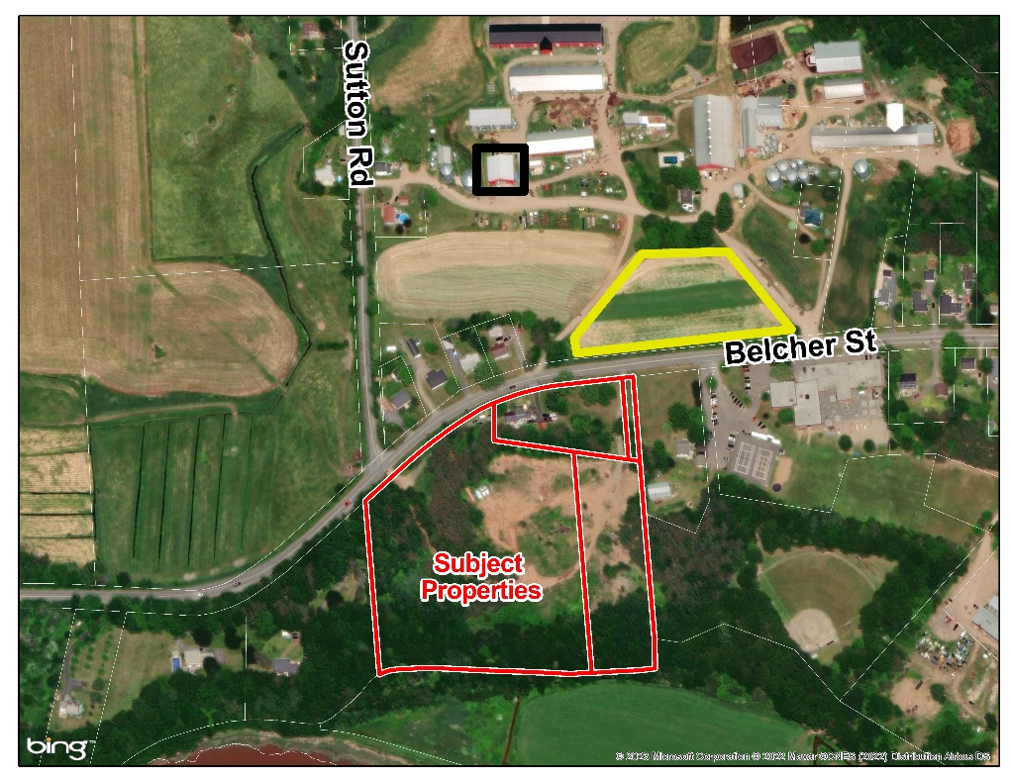

- Any required vegetative buffer shall include plant material that will grow to an approximate height of 20 feet (6.1 metres) or more in order to minimize the spread of fertilizer, pesticides and other sprays.
The proposed development does not incorporate any required vegetative buffers based on the other characteristics of the subject properties, particularly the topography that is present as a result of the former sand quarry operation and the current existing uses surrounding the subject properties.
- Vehicle access onto Collins Road is not permitted, with the exception of public roads, private driveways that resemble public roads, and driveways needed for safety purposes.
The proposed development is not located on Collins Road.
- Higher density areas are centrally located while lower density areas are located towards the Growth Centre fringe.
The subject properties are located on the fringe, but as discussed above, Staff are of the opinion that this development is appropriate in considering all other relevant information.
- The proposed design and maintenance adequately protect any identified wellfields;
The proposed development is not located within or near any wellfield protection overlays.
- For proposals involving subdivision, a minimum of ten (10) per cent of the development area is dedicated to public open space in accordance with the following criteria:
  - The location of public open space responds to policies 4.5.33 and 4.5.34; and
  - Up to seven (7) per cent of the public open space may include lands that otherwise could not be developed, such as drainage corridors, buffer areas , and wellfields.
Since this proposal does not include subdivision that would create new road infrastructure and the design of the proposal, the ten per cent open space contribution will be in the form of cash-in-lieu of land.
- In lieu of the ten (10) per cent land requirement a sum of money equal to five (5) per cent of the assessed value of the proposed lots, or a combination of land and money at a ratio 2:1 (land: money) may be accepted;
The property owner, in accordance with policy 3.1.13(j), a cash-in-lieu of land equivalent to 10 per cent of the value will be required.
- In addition to the [sic] any other information required, developers shall prepare a ground water study for proposals located within Wellfield Zones A and B. The ground water study shall be conducted by a qualified professional and shall assess the impact of the proposal on ground water quality and quantity and recommend measures for reducing any negative impacts; and
The proposed development is not located within Wellfield Zone A or B.
- The proposal meets the general development agreement criterial set out in section 5.3 Development Agreements and Amending the Land Use by-law;
This has been reviewed earlier in this report. Detailed responses are available for review in Appendix B.

DEVELOPMENT AGREEMENT SUMMARY
The draft development agreement contained in Appendix D contains the following:

- up to 210 residential units within a variety of built forms which includes two different building types, not including the existing one unit dwelling at a minimum density of 10 units per acre;
- community commercial use, subject to the requirements of the Mixed Commercial (C3) Zone, located in proximity to the road frontage;
- subdivision in accordance with the Residential Multi-unit (R4) Zone
- permits parking below and at grade. Below grade parking is permitted to extend beyond the building footprint provided it is not located closer than 30 feet from any property line;
- provision of a 100-foot wide agricultural buffer were no development is intended to occur although a walking trail is permitted to be located within this area;
- provision of a minimum of 100 square feet of amenity space per unit including a private balcony or patio;
- requires a low impact approach to stormwater management with a detailed drainage plan required at the time of permitting;
- Ten per cent Open Space contribution at the time of subdivision;

The draft development agreement has been written with the proposed development being the maximum level of development permitted on the subject properties with a small increase in the total number of residential units that represents rounding up the total number of units from 204 to 210. As Staff are of the opinion that the development, as proposed, is appropriate for this location, flexibility to enable less development, or in different built forms has been provided to accommodate changing market conditions or the ideas of a future owner.
The development agreement continues to require a minimum density of 10 units per acre, representing the density permitted in as-of-right development within the Residential One (R1) Zone, the Residential One and Two Unit (R2) Zone and the Residential Mixed Density (R3) Zone. Higher density development is required to be located to the rear of the existing vegetated area on the subject properties to provide a visual buffer from Belcher Street. All types of dwellings, including multi-unit dwellings, permitted within the Residential Mixed Density (R3) Zone are permitted to be located along the Belcher Street frontage, thereby maintaining the existing development opportunities that currently exist on the surrounding properties within the Growth Centre boundaries.

The permitted commercial use is required to be located in proximity to the Belcher Street frontage. The development of this use is not required by this Agreement and, should the owner opt not to develop this use, the development of residential uses in this area would continue to be permitted.

CONCLUSION
The proposed development would introduce additional housing resources in a built form that is not common within the Growth Centre of Port Williams on properties in proximity to zoning that permits multi-unit dwellings. The development has been designed to minimize impacts on neighbouring properties and nearby agricultural operations. As a result, Staff are forwarding a positive recommendation to Area Advisory Committee.

APPENDIXES
Appendix A –Maps
Appendix B – General Criteria for Development Agreements and Amending the Land Use By-law
Appendix C – Correspondence from the Public
Appendix D - Draft Development Agreement

APPENDIX A – Maps

Zoning Map

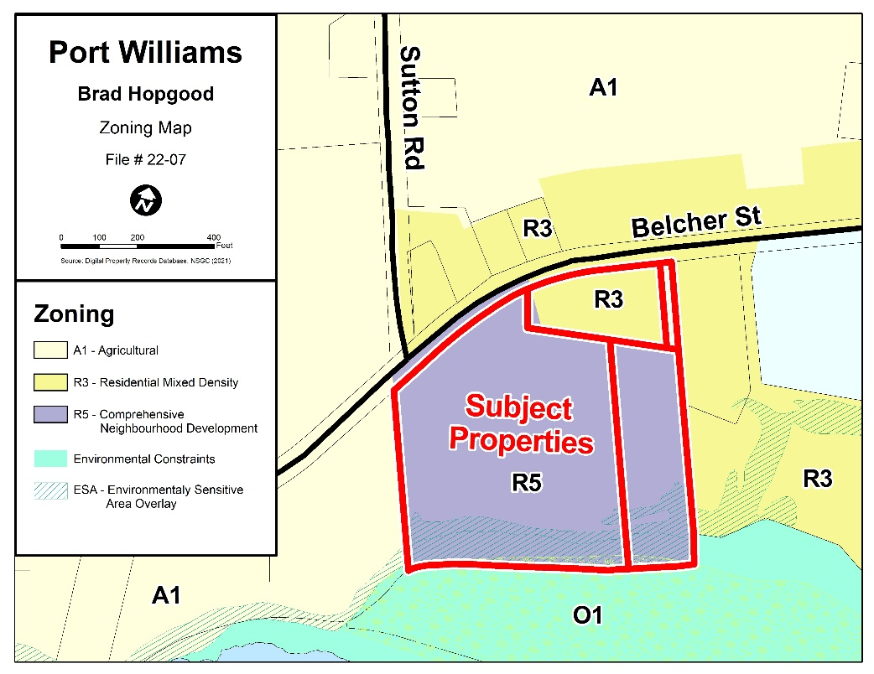

Future Land use Map
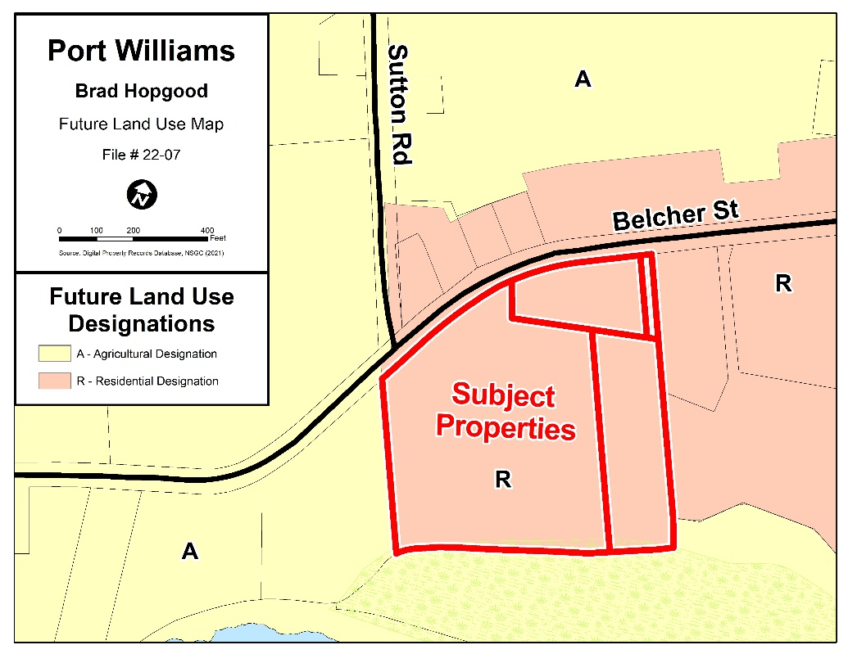

APPENDIX B – GENERAL CRITERIA FOR DEVELOPMENT AGREEMENTS AND AMENDING THE LAND USE BY-LAW

Policy 5.3.7
Council expects to receive applications to amend the Land Use By-law or enter into a development agreement for development that is not permitted as-of-right in the Land Use By-law. Council has established criteria to ensure the proposal is appropriate and consistent with the intent of this Strategy. Council shall be satisfied that a proposal to amend the Land Use By-law or to enter into a Development Agreement:

Criteria | Comments
a. is consistent with the intent of this Municipal Planning Strategy, including the Vision Statements, relevant goals, objectives and policies, and any applicable goals, objectives and policies contained within a Secondary Plan; | The proposal is in keeping with the intent of the MPS and the Port Williams Secondary Plan.
b. is not in conflict with any Municipal or Provincial programs, By-laws, or regulations in effect in the Municipality; | The proposal is not in conflict with any other programs, By-laws or regulations.
c. is not premature or inappropriate due to:
i. the Municipal or village costs related to the proposal; | The proposal requires an extension of sewer services westward along Belcher Street to the subject properties but it is the understanding of Staff that an appropriate costing and payment arrangement has been reached between the Property Owner and the Village of Port Williams.
ii. land use compatibility with surrounding land uses; | The surrounding neighbourhood is characterized by a mix of uses including a mix of residential and agricultural uses as well as an educational facility. The proposed development is compatible with these uses.
iii. the adequacy and proximity of school, recreation and other community facilities; | The proposed development is located in proximity to the Port Williams Elementary School. The Village of Port Williams has many recreational facilities within its boundaries for use by local residents including parks, a trail system and recreational programming offered through the Village. Staff requested information from the Annapolis Valley Centre for Education regarding school capacity and the ability for the area schools to accommodate new students. The Annapolis Valley Centre for Education indicated that local schools were near capacity but that the AVRCE is confident that they are well equipped to respond to enrollment increases.
iv. the creation of any excessive traffic hazards or congestion due to road or pedestrian network adequacy within, adjacent to, and leading to the proposal; | A Traffic Impact Study was provided by the applicant. This study was reviewed by Nova Scotia Department of Public Works as the authority having jurisdiction over Belcher Street. The Traffic Impact Study was determined to be acceptable and the department does not have any concerns.
v. the adequacy of fire protection services and equipment; | The Port Williams Fire Chief has indicated that fire protection is adequate in this area and will have no issues given the proposed development.
vi. the adequacy of sewer and water services; | The Village of Port Williams, as the owner and operator of the water and sewer systems within the Growth Centre, has indicated that there is adequate capacity in the system for the proposed development.
vii. the potential for creating flooding or serious drainage problems either within the area of development or nearby areas; | The property owner is required to control stormwater flows through the incorporation of low impact approaches for stormwater management. The Municipal Engineer is able to request the necessary reports and materials at the time of permitting.
viii. negative impacts on identified wellfields or other groundwater supplies for the area; | Not applicable – the subject properties are not within a wellfield protection area.
ix. pollution, in the area, including but not limited to, soil erosion and siltation of watercourses; or | Staff are satisfied that the proposal will not generate any pollution. The Property Owner will be required to follow provincial requirements related to erosion and siltation.
x. negative impacts on lake water quality or nearby wetlands; | There are no lakes or wetlands in proximity to the subject properties.
xi. negative impacts on neighbouring farm operations | There is a large agricultural operation on the north side of Belcher Street. Given the distance from the Subject Properties and the site layout, Staff do not expect any negative impacts beyond what might have been generated had the lands been placed in the same zone as the residential lands in the immediate vicinity of the subject properties.
xii. the suitability of the site regarding grades, soils and geological conditions, location of watercourses, marshes, bogs and swamps, and proximity to utility rights-of-way. | The proposed development represents the redevelopment of a former sand quarry. The site has good drainage and other characteristics suitable for development and is free of utility rights-of-way.

